**INFORMATION SECURITY MANAGEMENT (CSE 3502)**

**LAB-4**

**“Network Address Translation”**

**Name: Bhagath Singh.B**

**Reg.No. 17MIS1043**

* **The main use of NAT is to limit the number of public IP addresses an organization or company must use, for both the economy and the security purposes.**
* **NAT acts as firewall with a default deny policy for unregistered incoming packets, but no other rules.**
* **There are 3 types of NAT, static, dynamic and port address translation.**

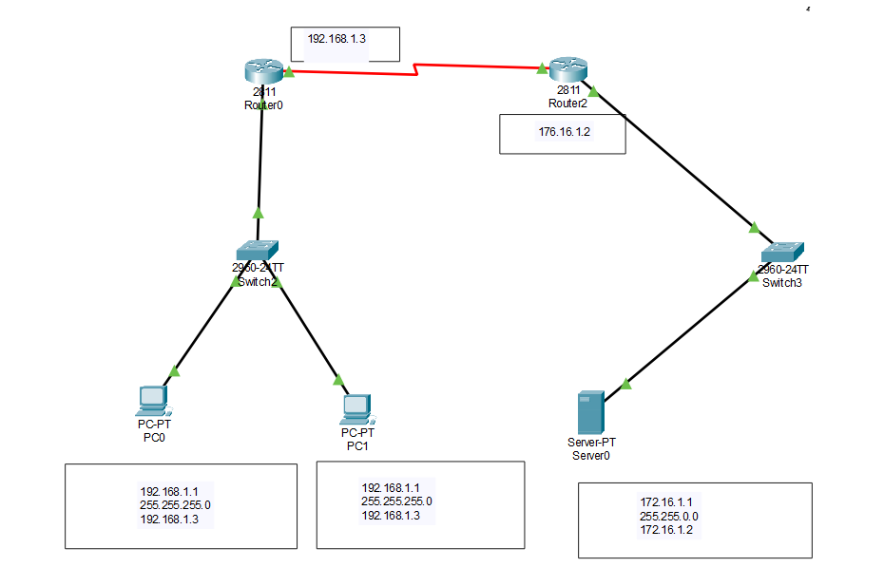

**Steps:**

**1) Initially we need to set the inside and outside IP address**

* **The Inside IP address will be the Fa0/0 interface to which the PC’s are connected.**
* **The outside IP address for the router will be the Se0/3/0 interface to which the server is connected.**

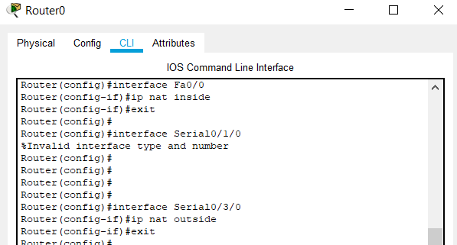

**2) Configuring the static NAT**

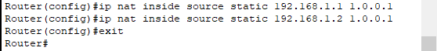

**3) Command to show IP network translation of the registered IP addresses in the NAT**

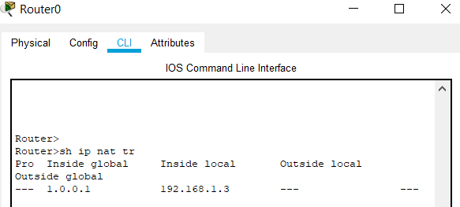

**4) Adding the router’s IP address which is the PC’s gateway to the NAT**

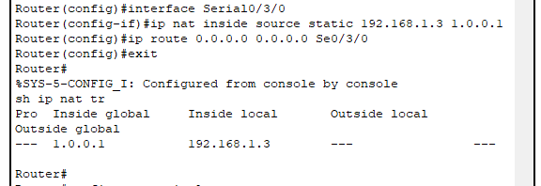

**OUTPUT:**

* **The successful transfer of packets from PC’s to the server in the network.**



* **The successful transfer of packets from server to PC’s in the network.**

